**Image Regression Task**

In this example, from a greenhouse experiment, 144 plants infected with a leaf spot disease have been photographed from top and manually assessed according to the severity of infection. The ratings go from 0 (healthy) to 100 (strongly infected).

The file ‘challenge_anno.txt’ contains two columns, the file name, and the annotation.

The challenge is, to create a deep learning model, that can predict the disease rating, from an input image. It should be evaluated if a performant model can be created from the given dataset.

Prepare an according training script, that loads the data and trains a deep-learning model in Python (using TensorFlow or PyTorch). Evaluate the performance of the model and prepare a prediction script that outputs the disease rating for a given image. Give suggestions how the performance could be improved.

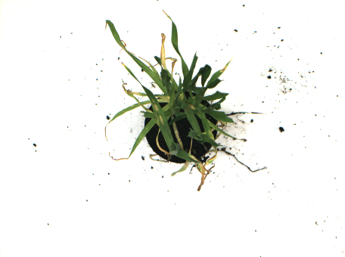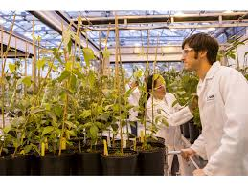

55